**Honey Soy Chicken Hokkien Noodles Heating Instructions**

Heat the Honey Soy Chicken sauce and mixed vegetables according to instructions in your Ingredients and Heating Guide.

For the Noodles

Using a Water Bath: Pre-heat the unit as normal. Once the water is hot place the pouches of noodles in – a maximum of 6 bags at one time.

Once hot simply open the pouches and separate the noodles with a fork, mix with your pre-heated sauce and vegetables to serve.

Alternate heating option: Open the pouches of noodles and place into a large heat proof bowl. Pour boiling water over noodles until submerged.

After 5 minutes gently separate with a fork or tongs. Drain away the hot water then simply mix with pre-heated sauce and vegetables to serve.

Note: 6 pouches of the noodles will take up to 50 minutes to heat in the water bath. Ensure you don’t leave them in longer than this as they will get too soft and fall apart.

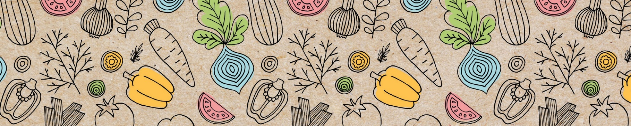

For younger children you may choose to cut the noodles up with scissors prior to serving to make them easier to eat – you will need to use your judgement of your individual centres needs.

[customerservice@kidsgourmetfood.com.au](mailto:customerservice@kidsgourmetfood.com.au)

